IBM uses a methodology referred to as “The Nine Levers of Scope” to define project implementation scope. It segregates total project implementation scope into nine discrete components identified below. These levers define the considerations & assumptions used for planning and estimating Oracle Cloud implementation project for <Client Name>.

Our scope considerations, assumptions and estimates are based on IBM’s current understanding of the requirements and information made available to IBM at this point of time. Deviations that arise during the proposed engagement will be managed through the change control process and may result in adjustments to the project scope, estimated schedule, charges, and other terms.

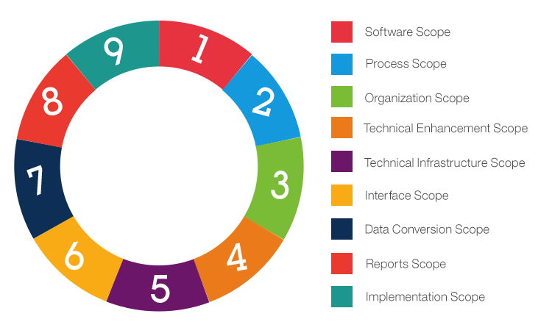
Figure 7: 9 Levers of scope

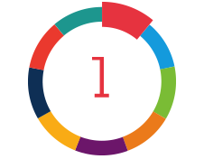
Lever 1 – Software Scope
The Software Scope lever defines Oracle products/modules which will be implemented as part of <Client Name> proposed Oracle Cloud implementation.

Following Oracle Products shared below should be considered as a reference only (commonly used modules). Please modify this table based on the requirements of a particular opportunity.

For Global Rollouts/Phased implementation, add a separate column to identify the phase a particular module belongs to/is planned to be implemented.

Oracle Part Number | Oracle Cloud Subscription Service (SaaS) | Oracle Modules (SaaS)
 | Oracle HCM
# B85800 | Oracle Fusion Human Capital Management Base Cloud Service | - Oracle Fusion Global Human Resources  - Oracle Fusion Onboarding  - Oracle Fusion Workforce Directory Management  - Oracle Fusion Benefits  - Oracle Fusion Absence Management  - Oracle Fusion Workforce Modeling  - Oracle Fusion Global Payroll Interface  - Oracle Transactional Business Intelligence  - Oracle Work Life Solutions  - Transparent Data Encryption
#B87388 | Oracle Fusion Human Resource Help Desk Cloud Service
#B89574 | Oracle Strategic Workforce Planning Cloud Service
<part number as per country>  US part no.  <# B86334> | Oracle Fusion Payroll Cloud Service for <supported country> | - Oracle Fusion Global Payroll  - Oracle Fusion Cash Management (restricted-use)  - Transparent Data Encryption  **Available for United States, Canada, Mexico, United Kingdom, China, India, Middle East.
# B94175 | Oracle Fusion Payroll Core Cloud Service | - Oracle Fusion Payroll Core  - Transparent Data Encryption
# B94174 | Oracle Fusion Payroll Connect Cloud Service | - Oracle Fusion Payroll Connect  - Transparent Data Encryption
# B94925 | Oracle Fusion Talent Management Cloud Service | - Oracle Fusion Performance Management Cloud Service  - Oracle Fusion Goal Management Cloud Service  - Oracle Fusion Talent Review and Succession Planning Cloud Service  - Oracle Fusion Career Development Cloud Service
#B94933 | Oracle Fusion Workforce Compensation Cloud Service | - Oracle Fusion Workforce Compensation Cloud Service  - Transparent Data Encryption
# B87675 | Oracle Fusion Recruiting Cloud Service | - Oracle Recruiting  - Transparent Data Encryption
# B95763 | Oracle Fusion Recruiting Booster Cloud Service
# B85242 | Oracle Fusion Learning Cloud Service | - Oracle Fusion Learning Cloud  - Talent Profile (limited use for the Learning Outcomes and Pre-requisites functionality only)  - Transparent Data Encryption
# B95657 | Oracle Fusion Learning Connect Cloud Service | - Oracle Fusion Learning Connect Cloud Service  - Transparent Data Encryption
# B75365 | Oracle Fusion Time and Labor Cloud Service | - Oracle Fusion Time and Labor Cloud Service  - Transparent Data Encryption
# B89482 | Oracle Fusion Workforce Health and Safety Incidents Cloud Service | - Fusion Oracle Fusion Workforce Health and Safety Incidents Cloud Service  - Transparent Data Encryption
# B94353 | Oracle Fusion Dynamic Skills Cloud Service | - Oracle Fusion Dynamic Skills  - Transparent Data Encryption
# B95499 | Oracle Fusion HCM Communicate Cloud Service | - Oracle Fusion HCM Communicate Cloud Service  - Transparent Data Encryption
# B95573 | Oracle Fusion Touchpoints Cloud Service | - Oracle Fusion Touchpoints Cloud Service  - Transparent Data Encryption
(a) # B93556  (b) # B93557 | Oracle Fusion HCM Journeys Cloud Service  (a) Hosted Employee  (b) Hosted Named User
#B91938 | Oracle Digital Assistant Platform for SaaS – Hosted Named User
#B89448 | Oracle Fusion Advanced Human Capital Management Controls Cloud Service – Hosted Employee
 | Oracle PaaS
 | Technical / PaaS | Oracle Integration Cloud Service –  Enterprise Edition
 | Additional Service | Additional Test Zone (4)  Oracle Guided Learning
 | Database  <include if any of the below are in scope>  1. OIC with integrations  2. End to end Data migration in scope | Oracle Autonomous Database

Overall Software Scope Considerations (General consideration…Please append opportunity specific considerations)

- Oracle Fusion Cloud latest released version before the start of the project will be considered in this proposal.
- IBM does not warrant the functionality of the in-scope Oracle Cloud modules. IBM will work with Oracle Corporation (product vendor) on behalf of <Client Name> in resolving problems related to the software. <Client Name> must have appropriate agreements with Oracle for such support.
- During Global Design or Co-create phase of the project, if it is found that some new modules will be required to be configured, such requirements will be managed in accordance with the Project Change Request procedure.
- Any changes to the modules listed in above table above must be managed in accordance with the project change control procedure.
- <Client Name> will retain ownership of and pay the cost of Oracle application software licenses/agreements including warranties and support costs (check with the OO if IBM is planning for SW resale for the specific opportunity).

Lever 2 – Process Scope

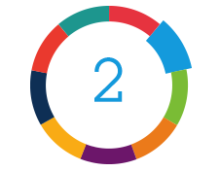
The Process Scope lever defines the business process areas that are in scope for this project. Process Scope encompasses business processes that are intended to exist in production.

The business process flows will be reviewed at the beginning of the project. IBM along with <Client Name> will assess fitment of the business flows with those of standard out of box Oracle cloud products.
The following business processes are considered to be in scope for this engagement:
Following Level 2 processes shared below should be considered as a reference only. Please modify this table based on the given/perceived processes of a particular opportunity (Industry specific processes should be considered)

Functional Area | Level 2 Processes
Core HCM | - Plan Workforce Deployment  - Manage Workforce Structures  - Manage Workforce Lifecycle  - Manage Employment Information  - Manage Promotion, Transfer & Termination  - Manage Workforce Records  - Manage Employee Relations  - Manage Environment Health & Safety  - Analyse Workforce Deployment  - Manage Social Networking
Absence | - Maintain Absence Enrolments  - Manage Absence Processing  - Manage Absences  - Report and Analyze Absence Data  - Schedule and Record Absences
Payroll | - Configure Payroll legislation  - Configure Consolidation Groups and Payroll  - Set up Pay Entities  - Setup pay rules  - Set up Third Party Payment Methods  - Set up Payroll Elements  - Configure delivered Statutory elements  - Configure delivered Balance Definitions  - Delivered online pay slips  - Set up Pension Scheme  - Single Tax reference  - Distribute Payroll Payments  - Distribute Payroll Accounting Information  - Manage payroll Outbound Interface
Goal & Performance Management | - Manage Goals  - Establish Worker Goals  - Define Organizational Goals and Measurements  - Define Worker Performance  - Evaluate Worker Performance  - Analyze Workforce Development Performance  - Delivered notifications  - Enable out of the box Mobile for HCM features with Oracle HCM Fusion Cloud
Talent & Succession Management | - Plan Organization Development Needs  - Define Organizational Goals and Measurements  - Assess Workforce Competencies  - Review Talent  - Plan Succession  - Manage Workforce Profiles
Learning | - Align Learning Programs with Competencies  - Manage Learning Programs  - Deliver Learning  - Manage Learner Enrolment and Completion
Recruiting & Onboarding | - Source and Manage Candidates  - Provide Candidate Services  - Manage Candidate Lifecycle  - Manage Job Offers  - Manage Job Requisitions  - Analyse Recruiting
Compensation | - Manage Compensation  - Manage Compensation Budget  - Manage Base Pay  - Manage Individual Compensation  - Manage Workforce Compensation  - Administer Workforce Compensation  - Manage Compensation Survey  - Manage Incentive Compensation  - Analyse Compensation Management
Benefits | - Manage Benefits  - Manage benefit Plans, Programs and Events  - Elect Benefits  - Maintain Benefit Enrolments  - Manage Benefits Billing  - Manage Stock Plans
HR Helpdesk | - Enable the HR Help Desk Profile Options  - Configure Queue Configurations  - Setting up Knowledge Management  - Configure Resource Organization (HRHD Users and equivalent Security)  - Enable self-service for employees and managers to open and track issues  - Reporting and dashboards based on case flow  - Customer to provide all Smart Text  - Configure Up to XX Queues to support helpdesk processes, XX intents to support ODA with XX FAQ components and XX KM Documents
Dynamic Skills | - Enable Skills Advisor for Candidates and Job Requisitions  - Enable Skills Advisor for Job Profiles in Profile Management  - Enable Skills Advisor for Learning  - Manage Skills recommendations and skills driven Talent management
HCM Touchpoints | - Enable Pulse surveys  - Enable Check-ins  - Manage employee engagements  - Enable engagement analysis
Advanced Controls | - Enable Data Privacy and Security Analysis for all HCM users  - Deep security analysis for HCM configuration & maintenance  - Enable Pre-built templates for core audit analyses  - Enable delivered Dashboards with analytics, alerts, and reporting

Overall Process Scope Considerations (General considerations…Please append opportunity specific considerations)
- <Client Name> will ensure current-state architectural diagrams, configuration, detailed design documents and related project documents are shared with IBM team before the start date of the project.
- <Client Name>’s as-is business processes will be altered to adapt to the business process supported out-of-the-box by the in-scope Oracle Cloud module(s).
- <Client Name> will designate an “Overall Business Process Owner” by Business functional area for this project. The “Overall Business Process Owner” will be responsible to facilitate working sessions with IBM and needed <Client Name> team members and to make key project decisions when “Business Sub-Process Owners” cannot agree to a common process where they intersect.
- <Client Name> will provide an experienced “Business Sub-Process Owner” for each of the in-scope major business process areas of this project. The “Sub-Process Owners” are knowledgeable and responsible for:
  - Actively participating in the to-be system design, build, test and training efforts.
  - Making the final business rules and process definition decisions for their area of responsibility.
  - Engaging peers and SME’s within <Client Name> as needed for clarification and/or reviews and alignment within the impacted organizations they represent.
  - Reviewing and signing-off the business requirements to be implemented in the Oracle SaaS solution along with the requirements’ clear test acceptance criteria.
  - Actively participating in User Acceptance Testing (UAT), signing-off on the final delivered Oracle SaaS functionality
- Any decisions where two or more organizations intersect and a decision cannot be agreed to by the respective Business Sub-Process Owners, the client’s Overall Business Process Owner is responsible to facilitate to a final harmonized business process rule or decision within the project’s milestone dates.
- Key required <Client Name> participants are available and actively participate within scheduled working design and build, CRP’s (conference room pilots) and UAT.
- <Client Name> will adopt standard process capabilities inherently available within the in-scope Oracle Cloud SaaS software:
  - If <Client Name> requires variation of business processes that requires customizations outside the out-of-the-box in-scope Oracle SaaS Cloud applications’ configurable capabilities, this will be addressed as a project change request.
- Implementation does not include activities associated with specialized SOX controls.
- Project scope, effort estimates, timeline and pricing will be validated, confirmed and updated as necessary at the end of the Discovery phase. Any resulting changes will be dealt with as per agreed upon Project Change Request process.

Lever 3 – Organization Scope

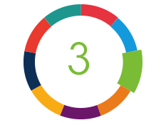
The Organization Scope lever defines the project’s impact on the organization and end-users, and outlines the change management activities included in the scope of the project.

The following tables define the geographical countries, currencies and workforce populations in <Client Name’s> organization (functional) that are included in scope for implementation in Oracle Cloud:

Geography | Country | Currency | # of Employees | # of Contingent Workers
North America | United States | USD
North America | Canada | CAD
North America | Mexico
EMEA | United Arab Emirates | AED

<< Update this table to include only the languages in scope>>

Language
Arabic
Chinese (Simplified)
Chinese (Traditional)
Dutch
English
French
German
Italian
Japanese
Korean
Portuguese
Spanish
Thai
Vietnamese

IBM will enable Oracle Cloud language packs in the languages listed in the table above
Project deliverables will be created in the English language only.
- <Client Name> is responsible for translating project documentation and training materials into any other language desired.

Organizational Change Management and Communications:

IBM will work with <<client name>> to discover and understand the current-state capacity for managing the transformation and in comparison to the anticipated user experience impact to develop a high-level roadmap for managing change.

Discovery Key Activities:
- Identify both executive and end-user audience to participate in transformation capability assessment
- Prepare, administer, and analyse transformation capability assessment
- Facilitate a working session to review the outputs from the transformation capability assessment
- Leverage the outputs of the future process modelling plan to compile the user experience impact assessment, identifying where change is required and to what degree
- Create heatmaps resulting from the user experience impact assessment to highlight change impacting both the functional areas and roles
- Prepare a high-level journey map that identifies key aspects of an organizational change management program that should be considered based on the results of both the transformation capability assessment and the user experience impact assessment

Discovery Deliverable:
- Change Management Readout
  - Summary of transformation capability assessment
  - Summary of user experience impact assessment
  - Strategic change management roadmap

Client is responsible to identify and designate appropriate Organizational Change Leader(s) and stakeholders to review transformation capability assessments, and creation of the strategic change management roadmap.

Training:

IBM will provide services to develop the following:
- Training Strategy
- Training Plan
- Training Content

IBM will impart training to the following audience
- <Client Name> Trainers
- <Client Name> Core Administrators
- <Client Name> Managers
- <Client Name> Employees

<Client Name> will identify key core users who need to participate in the training program. The training plan will be established during the project. IBM recommends a centralized training program including users from different geographical locations as “Change Agents” or “Super Users”. Following a “train-the-trainer” (T3) approach, IBM will train these Change Agent users, who will then lead the training of all end users within their location and organization of responsibility.

Training will be conducted after the solution has been finalized for the in-scope Software, Processes and Organizations. As per the level of training requirements identified during the Blue Printing phase, a phased training approach might be adopted for Application training and Business Process Changes.

Within the Training effort, IBM will support <Client Name> designated trainers during sessions (up to (X number) 2-hour sessions) to train Change Agents to become capable to lead the training efforts within their assigned geography and/or functional domain. (“Support” in this context means; helping to address questions or issues that arise during training and helping to close action items identified during the sessions.)

<Client Name> will provide all training facilities and administer all collaborative tools for training sessions. Daily training report will be published with follow up queries and clarifications before the next session.

Additional Organization Scope:

- <Client Name> will ensure availability and commitment of key customer stake holders to participate in dynamic delivery mode throughout the training period.
- Agreed work products and deliverables will be in English only and it will be the formal language of implementation, communication, and other project documentation.
- Any required translating of materials is the responsibility of <Client Name>.
- <Client Name> will ensure to include job aids and ready reckoners - like Guided Learning as add-ons to provide self-help for users working remotely.
- <Client Name> will provide a dedicated enterprise-integrated Training environment on which training will be conducted.
- <Client Name> representatives and executives will be available for meetings, workshops and review sessions as needed according to the project timeline. Any delay or non-availability of key customer resources will result in project delay and timeline shift and the cost implications will be addressed project change requests.
- IBM will provide its inputs to the training material to the client at least a week before the training session.
- Training sessions will be conducted virtually (such as WebEx or Zoom).
- Training sessions can be recorded for future reference and use.
- IBM will provide the training material to the client at least a week before the training session.
- IBM will facilitate Q&A sessions are held for the participants after each session.
- IBM will provide pre-recorded on-demand short videos on training content for clients to refer post training.

Oracle SaaS Cloud Testing

Testing cycles scope will be jointly agreed that <<Client Name>> developed scripts/scenarios can be executed with the available resources and within the project schedule for each testing cycle. Testing cycle responsibilities are outlined in the Responsibilities RACI.

Testing Cycle | Description | In Scope | Out of Scope
Unit Testing | Tests run to examine a single transaction or component (Level 4) of a business process (Level 3). Tests run to examine WRICEF objects (functional and technical). | As scheduled in Project Plan
Data Validation Testing | Tests run to validate that data has been loaded from one environment to another successfully. | XX test cycles in the Development environment  XX test cycles in the test environment
Systems Integrations Testing (SIT) | Tests run across business processes in different functional modules or interfaces to examine the connectivity between them. | Up to XX Test Scenarios  Up to XX Test Scripts  XX SIT Test Cycles | Automated testing
End-to-End Testing | Tests to verify that the system functions as expected. This test effort includes relevant business processes, integrations, and reports. | As scheduled in Project Plan  Up to XX Test Scenarios  Up to XX Test Scripts  XX E2E Test Cycles | Automated testing
User Acceptance Testing (UAT) | Tests that are designed to test specific business scenarios to verify system expectations are met. | Up to XX Test Scenarios  Up to XX Test Scripts | Out of scope for IBM
Regression Testing | Test run to confirm project effect on existing business processes | N/A | Out of scope for IBM
Performance Testing | Test end-to-end system performance response times | N/A | Out of scope for IBM

Testing exit criteria for each test cycle will be mutually defined in the Test Strategy document developed during the Shaping Phase.

During testing, identified issues will either be a Defect or a New Enhancement Request. IBM will work with <<client>> to address Severity Level 1 and 2 defects as defined below. New enhancement requests will be moved to backlog and agreed for development between Client and IBM through change requests.

- Defect: A deficiency in the software source code or process configuration where it does not meet the requirements documented in the signed-off functional/technical specifications and configuration documents. A defect must be directly linked to these signed-off project documents or directly linked to the Oracle SaaS Cloud delivered source code (e.g., third-party). IBM will assist and help facilitate the creation and resolution of Oracle Service Requests. IBM is not responsible for third-party defects.
- New Enhancement Request: Issues that do not meet the Defect criteria are considered new enhancement requests. New enhancement requests will use the Project Change Control procedures and will not be included in any exit or entry criteria for the test cycles.

Testing Defect Severity Classification
The objective of establishing testing severity levels is to provide a structure for introducing and implementing reasonable expectations for classification and fixing of errors. By categorizing errors, appropriate attention can be placed on problems that are of higher criticality. IBM will assign appropriate severities to the reported defects.

Severity Levels
Severity Level | Description | Example
1 | System failure. No further processing is possible. | Complete lack of system availability, results, functionality, performance, or usability
2 | Unable to proceed with selected functionality or dependent. | Subsystem availability, key component unavailable or functionality incorrect, and workarounds are not available.
3 | Restricted function capability; processing can continue. | Non-critical component unavailable or functionally incorrect; incorrect calculation results in functionally critical key fields/dates, and a workaround is available.
4 | Minor cosmetic change. | Usability errors: screen or report errors that do not materially affect the quality and correctness of function, intended use, or results

Hypercare
IBM and the Client will develop a Hypercare Support Plan that details support plans for after the go-live event.

- Hypercare duration (weeks)
- Number/Type of resources that will support Hypercare
- Activities (such as will the resources address only backlog, or enhancements of specific complexity and/or bug fixes)
- Indicate that Hypercare will be considered complete when its designated duration has elapsed, or when a report is submitted that outlines the exit strategy from hypercare and includes a plan to address any remaining open defects

Lever 4 – Enhancements Scope

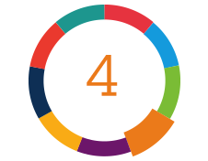
The Enhancements Scope lever defines enhancements to the core application software package performed by the project team that are included in the Software Scope. IBM will leverage processes supported by the inherent “leading practice” capabilities of the in-scope software.

The Software-as-a-Service Enhancement Objects included in scope are shown in the following table:
Enhancement Type | High | Medium | Low | Total
Fast Formula
Approval Workflows
Notifications
Personalization
Auto Complete Rule
Additional ODA skill
AI Agents

Overall Enhancement Scope Considerations (General considerations…Please append opportunity specific considerations)

The above is an estimate of Enhancements in-scope based on assessment of the <Client Name>’s business requirements. The same will be validated in greater detail in the Design phase workshops and during the Process/Journey Map Definition documents write-up. Any additional enhancements required to be included in scope will be managed through the project change control procedure.

- Unless otherwise stated in this statement of work, in the Oracle Cloud SaaS model, we do not consider any custom applications to be built on the Oracle PaaS platform.
- Workflow approvals will be configured using the out-of-the-box available approval management engine of in-scope software.
- <Client Name> will be responsible for any development, configuration, and testing activities for enhancements/extensions of external 3rd-party and legacy applications not explicitly stated in-scope in this SOW.

Lever 5 – Technical Infrastructure Scope
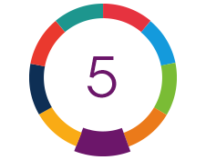
The Technical Infrastructure Scope lever defines the hardware, software, and network required to support the design, implementation, testing, and deployment of the modules and processes in scope in accordance with the project schedule.

Overall Infrastructure Considerations (General considerations…Please append opportunity specific considerations)

The following public model Oracle Cloud (SaaS) environments are required for this program and must be provisioned prior to the start date of the project:
- DEV: This environment will be used for configuration, developing RICE objects, and unit testing
- TEST: This environment will be used as a fully system integrated environment for end-to-end system integration testing (SIT) and user acceptance (UAT) testing

This environment will also be intermittently used as the training environment and will require significant planning and coordination.

- PROD: This environment will be used as the Enterprise Production environment

- Sandbox: An environment that can be frequently refreshed and used for proof-of-concept activities
- CONV: This environment will be used for the development and testing of data conversion.
- PAYROLL: This environment will be used for the configuration, data conversion and Parallel testing related to Payroll
- TRAIN: This environment will be used for training end users on the functionality in scope for deployment.

Additional Technical Infrastructure Considerations

- If during the detailed design, additional systems or modules are identified as being necessary to configure, such requirements will be managed in accordance with the Project Change Request procedure stated in – Project Change Procedure.
- <Client Name> will provide internet connectivity and necessary bandwidth required to access Oracle Cloud and other applications included in scope.
- <Client Name> will setup and provide any required computing environments, including installation of networking software, internet software, connections, etc.

- <Client Name> will have contractual agreements in place with Oracle for the provisioning, maintenance and support of the technical infrastructure to be sized accordingly to meet the <Client Name>’s performance related requirements.
- Oracle is the Hosting Service Provider and will provide the infrastructure and database administration support for the Oracle Cloud SaaS solution included in scope.
- Since the Oracle Cloud SaaS included in scope is hosted by Oracle, any services related to system performance, infrastructure, security penetration, disaster recovery/fail-over testing, maintenance downtime and environment availability are outside the scope of IBM’s services.
- In the event of adverse system performance related to standard Oracle functionality, IBM will work with Oracle Corporation (product vendor) on behalf of <Client Name> in addressing problems related to the software, but Oracle will be solely responsible for such issues. (Note: <Client Name> must have appropriate agreements with Oracle for such support prior to the project start date.)
- Performance Testing or Performance Tuning of standard Oracle product/functionality will be responsibility of Oracle. Any issues related to performance, security, maintenance, and availability of the cloud applications will be Oracle’s responsibility. In case of any adverse system performance related to standard Oracle functionality, IBM will create a support request with Oracle to get the fix, but Oracle will be solely responsible for it. If performance issue is reported on any custom functionality developed by IBM during testing, IBM will be responsible to fix the issue to the extent issue is traced to IBM development standards. IBM has not considered any separate performance testing phase for this project.
- All patching and upgrade related activities for the in-scope Oracle Cloud SaaS applications is outside the scope of IBM’s services. Impact assessment of changes by Oracle patches and any changes required due to the impact of Oracle patches will be subject to Change Request.

Lever 6 – Interface Scope


Interface Scope lever defines the interfaces needed to support the integration of the systems required by the proposed solution.

To be Integration Architecture (Insert Architecture diagram below)

Integration List: (Share the Integration Elements below, these are basic samples used)
Sl No | Interface Element | Source | Destination | Type | Complexity
1 | Employee Extract to Finance System | HCM Cloud | Finance System | Outbound | High
2 | Payroll to GL interface | HCM Cloud | Finance System | Outbound | Medium
3 | Time & Absence Data Extract | HCM Cloud | Payroll System | Outbound | Low
4 | Bank File – Direct Deposit | HCM Cloud | Bank System | Outbound | Low

Overall Integration Scope Considerations (General considerations…Please append opportunity specific considerations)

- IBM will solely determine the complexities of the development objects.
- Oracle Autonomous Integration Cloud, Oracle Data Integration Cloud and Oracle Database Cloud Service will be used as middleware platform for the Interfaces.
- Client will provide IT systems personnel for all legacy and periphery systems that have detailed data / systems knowledge that is required for the redesign and development of the interfaces and is responsible for their timely participation to support the project work plan.
- The technical specification template, naming standard, coding standard / best practices will be as per IBM standards and those will be approved by <client name> before start of the development.
- This scope and corresponding effort will be analysed during Design phase. Any additional required work identified will be managed through a Change Control Request
- <Client Name> is responsible to ensure that test & development environments for each internal/external system interfacing with Oracle Cloud are available to support the project timeline and associated milestones agreed to in the SOW.
- Error Management for integration will be done by out of the box Error Management pack included in Oracle Integration Cloud which serves the following activities – search & display errors, resubmit errors, view instance, view audit trails etc. There is no separate Error management framework been considered for integration.

Lever 7 – Data Conversion Scope
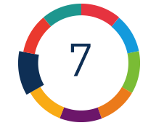
The Data Conversion Scope lever defines the conversion strategy and identifies those conversions that will be required to transition to the target environment.

In accordance with the modules in scope for implementation, the below list identifies the conversions in scope of the implementation. Any additional conversion items outside this list will be taken up as change requests under the Project Change Control Procedure.

Following Data Conversion elements should be considered as reference only. Please modify as per the overall module scope and conversion requirements

HCM:

Conversion Elements | Module | Mode | Historical Years | Complexity
Job Requisition Security Profile | Recruit & onboard | HCM Load
Content Library | Recruit & onboard | HCM Load
Geography Hierarchy | Recruit & onboard | HCM Load
Job Requisition Template | Recruit & onboard | HCM Load
Candidate Pool | Recruit & onboard | HCM Load
Referral | Recruit & onboard | HCM Load
Candidate Job Application | Recruit & onboard | HCM Load
Job Offer | Recruit & onboard | HCM Load
Job Offer Letter | Recruit & onboard | HCM Load
Agent | Recruit & onboard | HCM Load
Candidate Profile | Recruit & onboard | HCM Load
Job Requisition | Recruit & onboard | HCM Load
Action | Global Human Resources | HCM Load
Action Reasons | Global Human Resources | HCM Load
Business Unit | Global Human Resources | HCM Load
Grade ladder | Global Human Resources | HCM Load
Grade | Global Human Resources | HCM Load
Grade Rate | Global Human Resources | HCM Load
Job Families | Global Human Resources | HCM Load
Job Code | Global Human Resources | HCM Load
Location | Global Human Resources | HCM Load
Salary Basis | Global Human Resources | HCM Load
Department | Global Human Resources | HCM Load
Department Trees | Global Human Resources | HCM Load
Organization Trees | Global Human Resources | HCM Load
Position | Global Human Resources | HCM Load
Position Budget | Global Human Resouces | HCM Load
Position Hierarchy | Global Human Resouces | HCM Load
Person Data | Global Human Resources | HCM Load
Assignment Data | Global Human Resources | HCM Load
Work Relationships | Global Human Resources | HCM Load
Worker Contract | Global Human Resources | HCM Load
Assignment Supervisor | Global Human Resources | HCM Load
Assignment Work Measure | Global Human Resources | HCM Load
Assignment Eligible Jobs | Gobal Human Resources | HCM Load
Worker Seniority Dates | Global Human Resouces | HCM Load
Worker Extra Info | Global Human Resources | HCM Load
Worker Areas of Responsibility | Global Human Resouces | HCM Load
Person Document Records | Global Human Resouces | HCM Load
Person Images | Global Human Resouces | HCM Load
User Roles | Global Human Resouces | HCM Load
Enrolment Data | Benefits | HCM Load
Rates | Benefits | HCM Load
Balances | Benefits | HCM Load
Beneficiaries/Dependents | Benefits | HCM Load
Benefits Balances | Benefits | HCM Load
Salary | Workforce Compensation | HCM Load
ElementEntry | Workforce Compensation | HCM Load
Stock Grants | Compensation | Spreadsheeet Import/HCM Load
Rating Model | Talent Management | HCM Load
Education Establishment | Talent Management | HCM Load
ContentItem | Talent Management | HCM Load
Talent Profile | Talent Management | HCM Load
Performance Rating History | Talent Management | HCM Load
Succession Plan | Talent Management | HCM Load
Goals | Talent Management | HCM Load
Goal Plan | Talent Management | HCM Load
Talent Pool | Talent Management | HCM Load
Talent Review Meeting | Talent Management | HCM Load
Performance Document | Talent Management | HCM Load
Check-In Document | Talent Management | HCM Load
Feedback | Talent Management | HCM Load
Question | Talent Management | HCM Load
Absence Entries | Absence Management | HCM Load
Absence Balance | Absence Management | HCM Load
Time Cards | Time & Labor | HCM Load
Grievance & Disciplinary cases | HR Help Desk | HCM Load
Other HR Cases | HR Help Desk | Manual
Assign Payroll | Payroll | HCM Load
Create Calculations cards/ Calculation Card components/ Tax Withholding/ Reporting information Card | Payroll | HCM Load
Calculation card- TRU Assignment association | Payroll | HCM Load
Banks/ Branches/Bank Accounts/ Personal Payment Methods | Payroll | HCM Load
Pay Element Entries | Payroll | HCM Load
Involuntary Deductions/ Court Orders
Pay Balances / Accumulators (Element / Legislative/Summary/ Statutory) | Payroll | HCM Load
Historical Payslips | Payroll | HCM Load
Historical Year- End Documents | Payroll | HCM Load
Payroll Final Close – Terminated Employees | Payroll | HCM Load
Learning Content | Learning | Rest API
Legacy Learning Item | Learning | HCM Load
Noncatalog Learning Item | Learning | HCM Load
Training Supplier Resource | Learning | HCM Load
Classroom Resource | Learning | HCM Load
Instructor Resource | Learning | HCM Load
Course | Learning | HCM Load
Offering | Learning | HCM Load
Activity | Learning | HCM Load
Specialization | Learning | HCM Load
Learning Record | Learning | HCM Load

Data Conversion RACI

Key Tasks | Who will deliver | Who will review
Data Conversion Strategy Definition and Approach | IBM | <Client Name>
Identification of Conversion Objects | IBM | <Client Name>
Validation and sign-off of Data Conversion Strategy | <Client Name>
Identification of the source system tables/ files that contain the data required to be populated | <Client Name>
Data extraction Scripts development& Source data extraction as per IBM provided specification. | Data extraction from legacy source systems will be the responsibility of <Client Name> | IBM
Provide the Data Gathering Templates | IBM | <Client Name>
Data Mapping between source system and target system | <Client Name> | IBM
Perform Pre-Upload Data Transformations | <Client Name> | IBM
Loading of data into Oracle SaaS | IBM | <Client Name>
Data Cleansing | <Client Name> | IBM
Verification and validation of the accuracy and completeness of data loaded into the system during system testing and cutover (IBM will provide data reconciliation reports) | <Client Name> | IBM
Final Data Reconciliation, acceptance and signoff of data loaded into the system | <Client Name> | IBM

Overall Data Conversion Considerations (General considerations…Please append opportunity specific considerations)

Additional Data Conversion Scope Considerations:
- The project includes the following six (6) data conversion cycles in its scope estimate:
  - Up to three (3) conversion cycles into the CONV data conversion environment.
  - One conversion cycle into the DEV environment to for unit testing of build efforts in the DEV environment.
  - One conversion cycle into the TEST environment prior to beginning system integration testing.
  - One conversion cycle into TEST prior to the start of user acceptance testing of the application.
  - Final conversion into PROD during go-live cut-over for production.
- <Client Name> will provide automated or manual conversion files before the start of << specify an estimated date per the project timeline>>.
- <Client Name> will provide IT systems personnel that have detailed data / systems knowledge that will be required for the gathering of data specific requirements, reviewing data conversion reports, and cleansing of data issues.
- <Client Name> is responsible to ensure availability and commitment of key business stake holders to participate in data reconciliation process
- <Client Name> will validate and provide a sign-off on historical data for loading into the system before the UAT phase.
- Data cleansing in existing systems will be the responsibility of <Client Name>.
- IBM solely determines the complexities of the development objects.
- Archiving of legacy application data is client’s responsibility.

- Active in-progress transactions will be either closed out in the legacy tools by the client OR be manually keyed in by the transaction’s business owner.
- The data stored within the Oracle SaaS Cloud platform is not considered sensitive data and does not require data encryption.

Lever 8 – Reports Scope
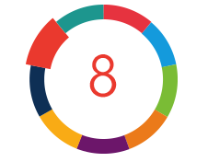
The Reports Scope lever defines the transactional and operational reports that are to be developed using the out-of-the-box reporting capabilities available in the Oracle SaaS Cloud module(s) included in the scope of the project.

IBM will design, develop, test and deploy a total of XX custom reports to be delivered in Oracle Cloud SaaS. These reports will be implemented in the following native Oracle Cloud SaaS reporting tools:
Oracle Transactional Business Intelligence (OTBI)
Oracle Business Intelligence (BI) Publisher

The table below lists the counts of reports by tool and complexity included in scope for this implementation:

Reporting Tool | Complexity |  |  | Total
Reporting Tool | High | Medium | Low | Total
BI Publisher | - | - | - | -
OTBI | - | - | - | -
Total | - | - | - | -

Report Complexity Defitions:

BI Publisher –
- High (up to 5 data source tables and template groups, includes bursting)
- Medium (up to 3 data source tables and template groups)
- Low (up to 2 data source tables and template groups)

OTBI –
- High (Multiple Layouts, Drill down to level 3)
- Medium (Multiple Layouts, Drill down to level 1)
- Low (Single Layout, No Drill down)

Overall Reporting Considerations
- Delivered reports will be leveraged wherever available. Other than the listed reporting requirements, all other reporting requirements will be met by out of box reports.
- Multilanguage support for reporting is not in scope. The language of development will be English only.

Lever 9 – Implementation Scope


The Implementation lever defines the steps of the transformation lifecycle starting from business process understanding to transition to the new process and application.

Deployment Plan (Summary):
[Insert the Summarized Project Plan here]

Services are estimated to start on X and will be performed based on the estimated schedule below. The estimated end date for the Services is X.

IBM will use IBM’s Oracle Cloud RapidMove methodology to implement the scope of functionality as described in this document.
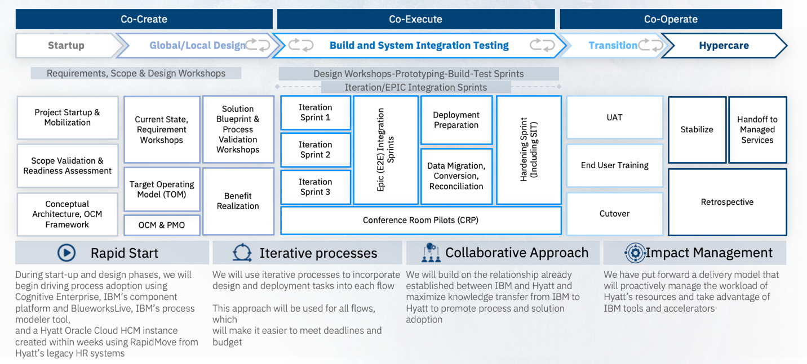

Implementation Plan
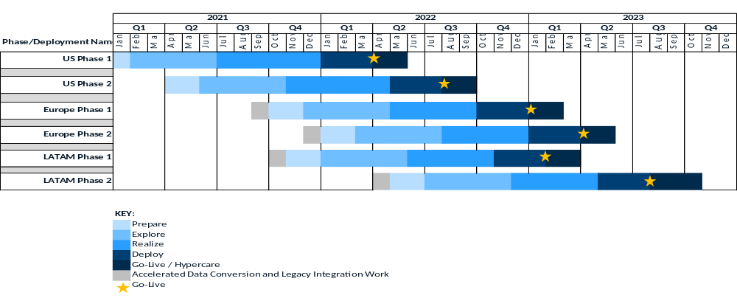
Sample

Oracle Cloud (SaaS) Testing
Testing cycles scope will be jointly agreed that the scripts/scenarios developed for Client can be executed with the available resources and within the project schedule for each testing cycle. Testing cycle responsibilities are outlined in the RACI chart

The following testing activities are included in the scope:
Testing Activity | Description
Unit Testing | Tests run to examine a single transaction or component (Level 4) of a business process (Level 3). Tests run to examine WRICEF objects (functional and technical).
Functional Testing | Tests to verify that the system functions as expected. This test effort includes relevant business processes, integrations, and reports.
Data Validation Testing | Tests run to validate that data has been loaded from one environment to another as per mutually agreed upon exit criteria.
System and Integration Testing (SIT) | Tests run across all business processes in different functional modules and/or interfaces to examine the connectivity between them. This also includes end to end testing of critical business scenarios as mutually agreed.
User Acceptance Testing (UAT) | Tests that are designed to test specific business scenarios to verify system expectations are met.  This cycle is meant to test a subset of key test scenarios by module to ensure the top critical processes/test scenarios are working as per the design
Regression Testing | Test run to confirm project effect on existing business processes.
Performance Testing | IBM will coordinate with Oracle for matters related to Oracle system performance (provided Client has signed up for this service with Oracle).

Testing exit criteria for each test cycle will be mutually defined in the Test Strategy document.

During testing, identified issues will be classified as a Defect or a New Enhancement Request. IBM will work with Client to address Severity Level 1 and 2 defects as defined below. New enhancement requests will be moved to a backlog and agreed for development between Client and IBM through change requests.

- Defect: A deficiency in the software source code or process configuration where it does not meet the requirements documented in the signed-off functional/technical specifications and configuration documents. A defect must be directly linked to the signed-off project documents or directly linked to the Oracle Cloud (SaaS) delivered source code (e.g., third-party). A software source code defect will be managed by Client logging a Service Request (SR) with the software provider, Oracle, for resolution. IBM will assist and help facilitate the creation and resolution of Oracle Service Requests. IBM is not responsible for third-party defects.
- New Enhancement Request: Issues that do not meet the Defect criteria are considered new enhancement requests. New enhancement requests will use the Project Change Control procedures and will not be included in any exit or entry criteria for the test cycles.
Testing Defect Severity Classification
The objective of establishing testing severity levels is to provide a structure for introducing and implementing reasonable expectations for classification and fixing of errors. By categorizing errors, appropriate attention can be placed on problems that are of higher criticality. IBM will assign appropriate severities to the reported defects.

Severity Level | Description | Example
1 | System failure. No further processing is possible. | Complete lack of system availability, results, functionality, performance, or usability
2 | Unable to proceed with selected functionality or dependent. | Subsystem availability, key component unavailable or functionality incorrect, and workarounds are not available.
3 | Restricted function capability; processing can continue. | Non-critical component unavailable or functionally incorrect; incorrect calculation results in functionally critical key fields/dates, and a workaround is available.
4 | Minor cosmetic change. | Usability errors: screen or report errors that do not materially affect the quality and correctness of function, intended use, or results

System Integration Testing
- IBM will provide the SIT scripts created to Client.
- Client will review business scenarios included in the SIT scripts to ensure all critical and high impact business scenarios are included the SIT scripts.

- User Acceptance Testing à IBM has designated <XX> weeks of Operational acceptance testing between at the end of SIT to familiarize the users on Oracle Cloud process flow with end-to-end testing.
  - During UAT, IBM will conduct live conference sessions at a pre-scheduled time each day with process owners to address clarification and questions.
  - Business users will refer to guided learning videos of training sessions during UAT execution.

- Cutover Planning & Execution à
  - IBM will introduce an additional Mock-cutover cycle for in-scope run book steps to facilitate sequencing, execution, and validation of activities.
  - IBM will execute mock conversion for the agreed key objects with near production data.
  - <<Client Name>> will ensure access to key stakeholder and non-prod environment of impacted systems during mock cut over.

Overall Implementation Considerations (General considerations…Please append opportunity specific considerations)

- It is the responsibility of <<Client Name>> to make sure that there will be no impact due to any other Oracle / Non-Oracle project on this implementation project. In case of any impact, change request will be raised for additional scope, staffing, timeline.
- Client team will have all necessary knowledge and documentation on the legacy and any Oracle /non-Oracle applications. Client will provide all documentation related to their current application architecture. If such documentation is unavailable or incomplete, then this may have an impact on the project timelines.
- <<Client Name>> will be responsible for planning, coordination, and execution of UAT.
- <Guidance> The parties acknowledge and agree that COVID-19 is an event beyond the parties’ reasonable control, and it is not possible to foresee (or advisable to try and foresee) its duration, impact, or extent (including measures and recommendations that may be put in place by regulators). As such, where a party's non-monetary obligations are not performed, affected, and/or delayed and that is attributable to COVID-19 or its related impacts, notwithstanding any other provision in the agreement, the affected party will not be responsible for such non-performance, affected performance or delay. The parties will act reasonably to discuss the affected obligations, potential workarounds and related issues in good faith and will document any agreed changes to the agreement utilizing the Project Change Control Procedure

